Document Number: 000xx Document Issue: 0.1
Date Issued: January 8, 2002 Document Status: Draft
                - Filing Path:
                - Document Title: radsound
                - Author: Tim Hinds
                - Keywords: radsound

Introduction
radsound is Radical’s core sound technology. It provides a system abstract audio interface. That is, it simplifies audio development by presenting a single audio interface for multiple platforms.

Scope and Objectives
To provide a high level overview of the services provided by radsound, and how it is realized and limited by each platform.

Intended Audience
Anybody interested in learning about radsound, especially programmers, and sound designers.

References
None.

Platform hardware organization
Although the radsound library completely hides the platform on which it is being run, it is very important for the user to understand the basic layout and features of each hardware platform. Certain optimizations, such as which memory space to buffer data, or the impact on CPU usage when using effects must be understood to maximize game performance.

Playstation2 Hardware
The Playstation2 audio hardware is very similar to the original Playstation hardware; in fact the Playstation2 hardware contains a Playstation and in this way is truly backwards compatible. The Playstation2 replaces the Playstation’s single Sound Processing Unit (SPU) with two slightly enhanced versions of the chip. Each SPU is referred to as a “Core” as in Core1 and Core2. Each core has a single effects unit, which has simple presets such as reverb, delay, and chorus, with few parameters to manipulate.
The SPUs address about 2 Megs of dedicated audio memory that can only be accessed by the SPUs. To modify this memory it must be DMA’d from IOP (IO Processor MIPS 33MHz) memory. Further this IOP memory is not addressable from the main CPU on which most of the game AI code exists, thus there is a very complicated audio and command data path on the Playstation2. The SPU registers are mapped into IOP memory space, which means in cannot be accessed from the Main Processor running the AI code. An intermediate RPC (Remote procedure call) mechanism has been implemented to facilitate issuing commands from the EE to the IOP and this to the SPUs.
Hardware ADPCM (compressed) playback
Each core mixes 24 mono voices, totaling 48. Each voice is capable of playing back a Sony proprietary compressed mono ADPCM (Adaptive Pulse Code Modulation) data. There is no built in support for playing interleaved stereo data. Each voice has hardware support for pitch, envelope (ADSR), volume, and a switch to send it to the effects unit on its core.
PCM (uncompressed) playback
Each core can also playback a single stereo PCM stream at 48KHz (DVD quality). The stereo PCM data is interleaved in chunks of 512 bytes (256 left/ 256 right). There is no pitch control and thus data must be 48KHz. In addition there is a single hardware stream per core, so mixing of multiple sources must be done in software on the IOP. Software mixing 48KHz data is rather impractical due to heavy processing loads that would be incurred
Other
CD is read into IOP memory before it can be transferred to Main or SPU memory—the shortest data path is IOP memory to SPU memory via DMA. Any file buffering should probably be done in IOP memory.
Source data sampling rate should be related to 48KHz. For example 41KHz (CD Quality) data cannot be played back accurately, the pitch value gets truncated when set. 24KHz is probably the best.

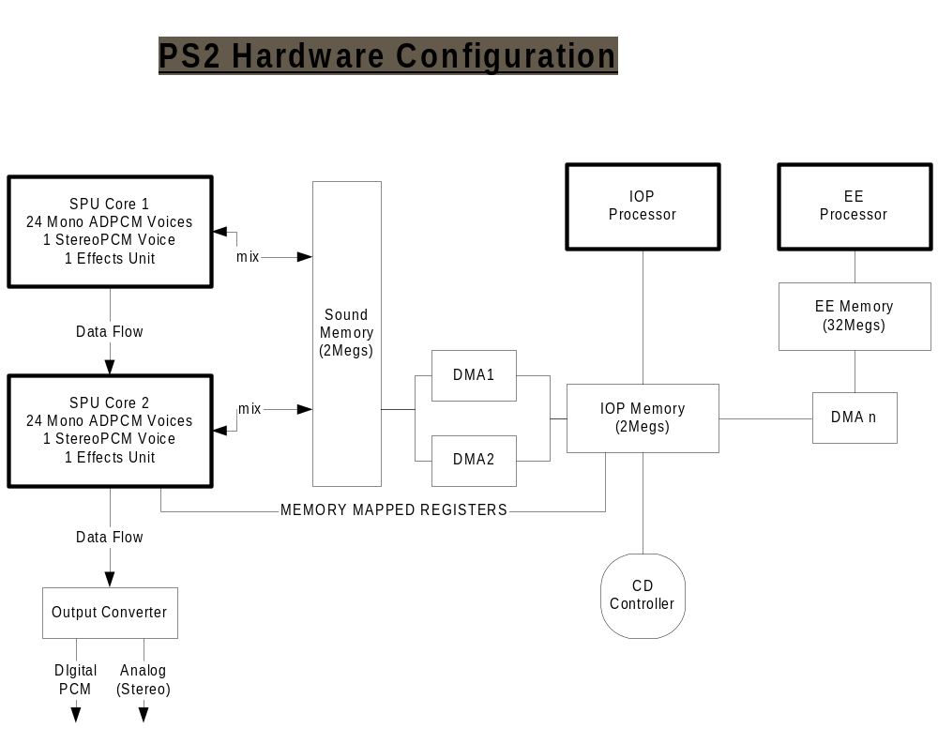

Game Cube Hardware
The GameCube has two memory spaces Main Ram (24 Megs) and ARAM (Auxiliary Ram). The Sound Processor hardware mixes data buffers in ARAM—this means the data must be DMA’d from Main Memory to ARAM before it can be played. The Sound Processor is controlled through command buffers which are DMA’d to and from ARAM once every few milliseconds.
Voices
The Sound Processor hardware-mixes 64 mono voices of PCM or 16 bit ADPCM data. Each voice has a pitch control and the following 3 volume controls on 3 separate busses, Main, Aux A, and Aux B. The mix main bus signal is sent directly to the outputs. The mixed voice output of Aux A and Aux B are treated with effects and then is mixed with the main output.
Effects
The game cube can run two effects simultaneously. Each effect is assigned to an Auxiliary Bus (A or B). The mixed auxiliary send data is DMA’d from ARAM to Main Memory and an interrupt is triggered. The Main CPU interrupt handler processes the data, and when it exits, the processed effect data is send back to ARAM and is mixed with the main bus outputs. Note that main CPU bandwidth will be used for each effect. Some reverbs are extremely expensive to calculate.
Other
Note that the game cube CD controller reads data into Main Ram and cannot directly read into ARAM. The game cube also provides a hardware CD streaming mechanism for a single stream, but the radsound libraries do not currently use it due to this single stream limitation.

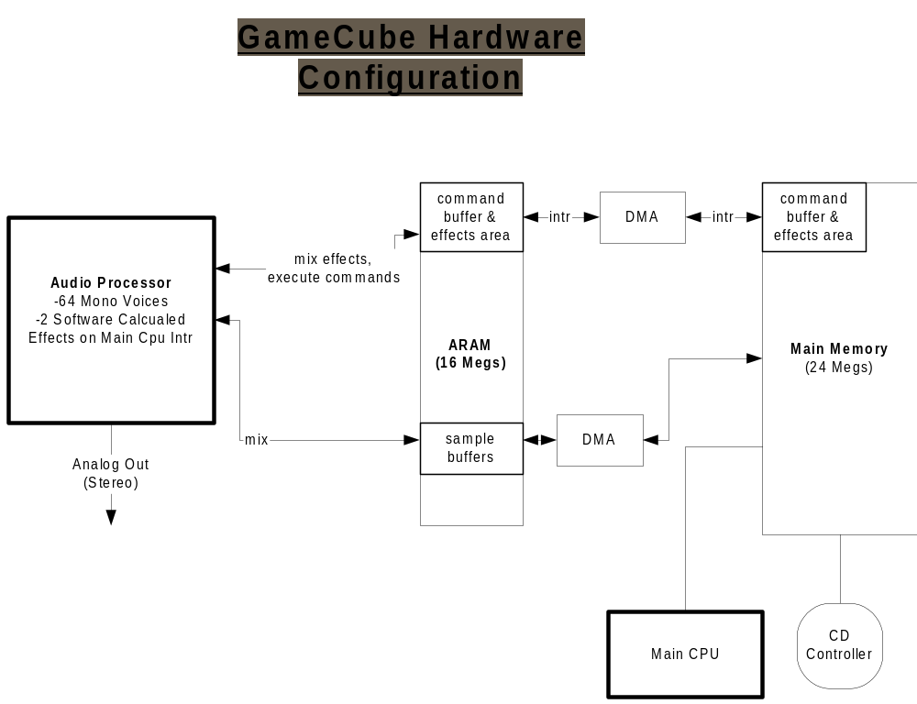

XBox Hardware

Windows Hardware
Hardware on the windows platform is unknown to the developing application. The application codes to the DirectSound SDK.
DirectSound
DirectSound simply provides software mixing of an “infinite” number DirectSound buffers. These DirectSound buffers are not simply main memory buffers, but rather an abstraction of the memory space on which they exist. Originally (the 486 Days) sound cards had much more onboard RAM to compensate for the low bandwidth ISA busses, and DirectSound Buffers were actually often on the cards. Now days all sound cards are glorified DA converters with fancy packaging. The device driver simply provides a means of getting the DirectSound software mixed PCM stream in main memory to a very small buffer on the card (to compensate for bus latencies). The only real difference between Creative’s sound card models is the software they are bundled with—they all use DirectSound’s “emulation” or less often their own “software hardware” device drivers. Rarely is there any circuitry of any significance on the card.
DirectSound provides a somewhat crude 3D algorithm and DirectSound8 introduced some software effects with a better audio-path graph model. DirectSound is improving all the time but is carrying substantial legacy interface baggage. There are some fundamental basic interface problems that must be addressed before it can progress much further. These shortcomings make developing and maintaining radsound on Windows frustrating because it is certainly the most restrictive in capabilities.
Currently DirectSound supports only PCM data playback.
Software Mixing
Because DirectSound has really just become a software layer, the approach that most pro-audio applications take is to create a single DirectSound buffer that plays all the time. The application then performs its own software mixing into this single buffer. It is then free to design its audio system, its effects, signal-graph, and other concepts properly without the legacy baggage and unknowns that come along with using DirectSound’s mixer and effects-path model.

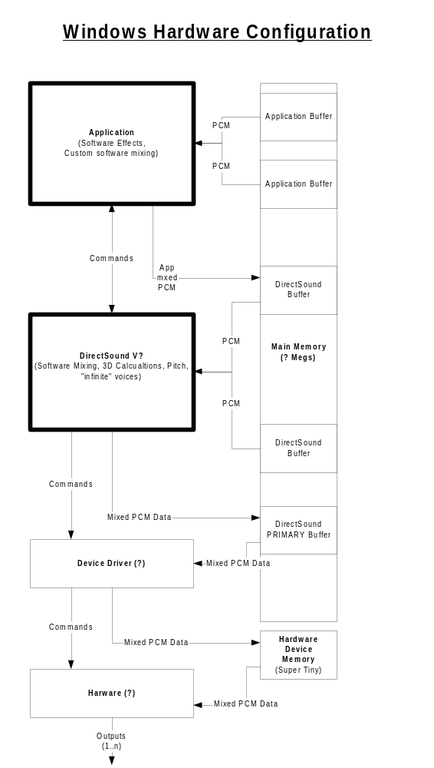

Class Specifications

Class Name: Singleton

Description
<Provide a description of the class - what does it do, what are its main purposes, etc.>

Public Interfaces
<Describe in text each of the public interfaces for the class.>
The public interfaces provided by the class Singleton are:
- Instance: Provides a means by which to access the Singleton class to instantiate it; this method hides the constructor from the public and limits the number of instances of the class to one.

Class A

Description
<Provide a description of the class - what does it do, what are its main purposes, etc.>

Public Interfaces
<Describe in text each of the public interfaces for the class.>
The public interfaces provided by the class ClassA are:
- OperationA1: This method is responsible for …
- OperationA2: This method is responsible for …

Class B

Description
<Provide a description of the class - what does it do, what are its main purposes, etc.>

Public Interfaces
<Describe in text each of the public interfaces for the class.>
The public interfaces provided by the class ClassB are:
- OperationB1: This method is responsible for ….

Dynamic Behavior
<This section provides an overview of the major scenarios that involve dynamic behavior, it shows the classes/components and how they dynamically communicate for a particular scenario.>
<Events happen dynamically in all software-intensive systems: objects are created and destroyed; objects send messages to one another in an orderly fashion; and in some systems, messages are sent simultaneously. Describing a dynamic event in a static medium is a difficult problem, in object-oriented software design we capture this behavior in two different diagram types:
- Sequence Diagrams
- State Diagrams
>

Sequence Diagrams
<Sequence diagrams show the dynamic behavior of the design. Sequence diagrams show how the objects (instantiated classes) in this design interact with each other (i.e., method invocations) and how they interact with external entities (i.e., those in a different sub-system). Note that it is important that the diagrams show the order of how objects interact with each other>
<Describe the sequence diagram and each of the operations associated with the sequence - for example, perhaps it shows the sequence of operations that are called when a user of a game selects the options menu for a game.>
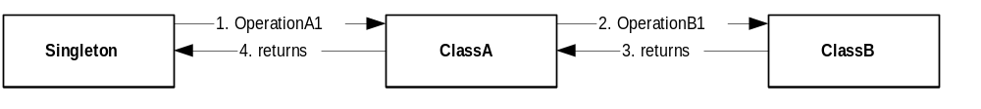
Figure 4-1 Sequence Diagram for …
<NOTE: Depending on the software tools available and the expertise of the developer using the tools, sequence diagrams can be created in MS Word using the Drawing Tools, Visio, or Rational Rose 98>

State Diagrams
<This section may be omitted if there is no state specific information associated with the design.>
<State diagrams should be provided for any complex classes that are highly based on state machines or based on the "state" pattern. If part of the major design of a class or set of classes is dependent on a states/contexts then it is important to explain these states and the transitions between these states.>
<NOTE: Depending on the software tools available and the expertise of the developer using the tools, State diagrams can be created in MS Word using the Drawing Tools, Visio, or Rational Rose 98>

Class A
Class A is based on a state machine that has 3 states and multiple transitions. The states and how to transition from one state to another are described below.
States:
- State1: This state is used for …
- State2: This state is used for …
- State3: This state is used for …
Transitions:
- Transition1: This transition happens when …
- Transition2: This transition happens when …
- Transition3: This transition happens when …
- Transition4: This transition happens when …
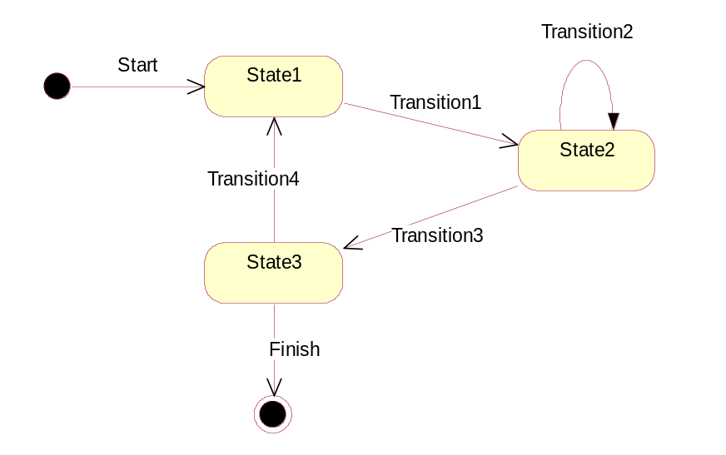
Figure 4-2 Class A State Diagram

Platform Considerations
<This section describes any special considerations that need to be accounted for with respect to platform the software is being developed for. Platforms may include PC, PS2, PSX, Dolphin, Wireless, Advanced Game-Boy, etc.>
<Note if this section is not relevant to your design document then it can be removed or "NONE" can be specified.>

Summary

Risks
<Describes any foreseeable risks that are associated with the technical design - this may include

Dependencies
<List any internal or external dependencies that exist. This may include the development/delivery of internal tools or foundation components that are required for this technical design; and/or the evaluation/purchase/delivery of external tools or software components.>

Overall Effort Estimate
<The cost of a class must include the costs for implementation, unit testing, and code review; and any other implementation related tasks/overhead>
The cost of implementing this project is:
Class/Component Name | Estimate in Person Days
Class Singleton | 1 days
Class A | 3 days
Total | 4 days

